 | Problem 1 | Problem 2 | Gridded Response
Tuesday | Write a fraction to represent the number of moons to the total number of shapes. | What is the value of  (15-3) + 8 ÷ 4 × 2 | Problem 2  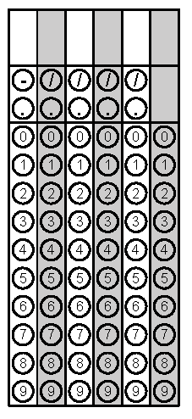
Wednesday | Write an expression to represent “for each of five days, Tony bought a $1.50 drink and a $2.50 snack.” Then determine how much Tony spent in all 5 days. | Mario is designing a video game and has to build the board so that no square in the game is more than 25in². What is the longest side length any square could have? | Problem 2
Thursday | What is the volume in cubic inches of a sand box with the following dimensions?  Length 9 in  Width 4 in  Height 2 in | Solve and graph the inequality on a number line. $x-8≤16$ | Problem 1
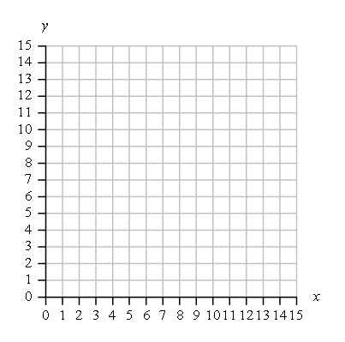  Friday | Find the coordinates for point B so that line segments $\overline{AB}$ and $\overline{CD}$ will be parallel.  Point Location  A (2, 11)  B  C (5, 7)  D (12, 7) | Mrs. Jacobi’s class made a line plot to show the number of pets each student has.  What is the total number of pets for the class?  X  X X X  X X X X  X X X X X  0 1 2 3 4 | Problem 2

