 | Problem 1 | Problem 2 | Gridded Response
Monday | Write in expanded form.  $${\left(\frac{2}{5}\right)}^{4}$$ | Evaluate ${\left(3×4\right)}^{2}$ | Problem 2  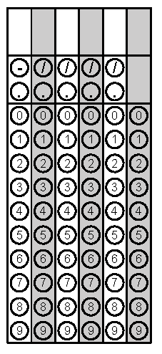
Tuesday | What is 5.0 – 1.7? | Solve the problem below and bubble the answer into the gridded response.  6021  - 593 | Problem 2
Wednesday | Solve the inequality.  $$x-8≤16$$ | Covert the mixed number into an improper fraction.  $3\frac{2}{5}$ | Problem 2
Thursday | Michaela’s room is 12 feet wide by 8 feet long. Her brother’s room is half as wide but twice as long. Whose room is bigger? | What is the volume of this figure? | Problem 2
Friday | Order the numbers from LEAST to GREATEST.  3.5, ½ , ¾ , 3.025 | Below is the weight of five football players from each team. What is the median weight of Steelers?  Cardinals Steelers  Mike Gandy 316 Max Starks 345  Reggie Wells 308 Chris Kemoeata 344  Lyle Sendlein 300 Justin Hartwig 312  Duece Luti 332 Darnell Stapelton 305 | Problem 2

