 | Problem 1 | Problem 2 | Gridded Response
Monday | Cristofer and two of his friends go out to eat. The bill is $28.08. How much did each person pay if they split the bill evenly? | For babysitting her cousins for 4.5 hours, Ciera’s aunt pays her $36. How much did Ciera make each hour? | Problem 1  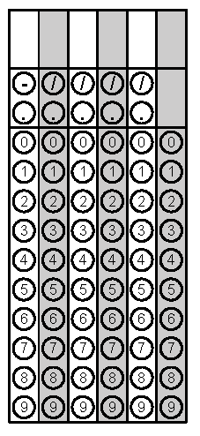
Tuesday | Evaluate using order of operations.  $$\frac{2^{3}}{{\left(18-4×3\right)}^{2}}$$ | Makiya has $5.40, but her brother, Kalil, has $7.80. Altogether, how many dimes do they have? | Problem 1
Wednesday | If ${10}^{x}=10,000$, what is the value of x? | Simplify: $\left|-2\right|$ | Problem 2
Thursday | List the first 15 perfect squares in order from least to greatest  ____ , ____ , ____ , ____ ,  ____ , ____ , ____ , ____ ,  ____ , ____ , ____ , ____ ,  ____ , ____ , ____ | If ${10}^{x}=100,000$, what is the value of x? | Problem 2
Friday | Plot the rectangle with vertices at (3,4), (11,4), (11,12), and (3,12). If diagonals are drawn, what are the coordinates of the point where the diagonals will meet?  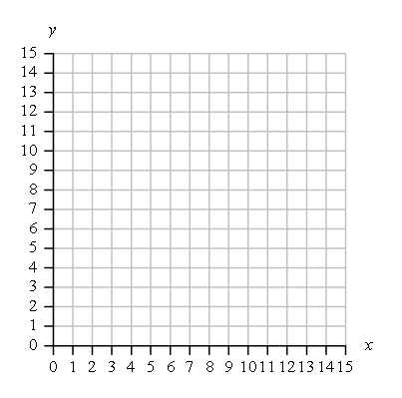 | What is the GCF of 24 and 36? | Problem 2

