 | Problem 1 | Problem 2 | Gridded Response
Monday | List the first 15 perfect squares.  ____, ____, ____, ____,  ____, ____, ____, ____,  ____, ____, ____, ____,  ____, ____, ____ | Simplify  $$\frac{3}{4}+2 \frac{1}{4}$$ | Problem 2  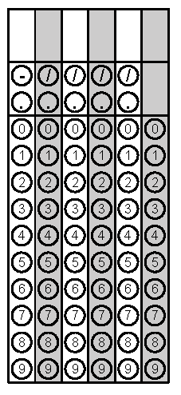
Tuesday | Simplify the Expression:  5y² + 3y – y + 2 | Find the area and perimeter of the rectangle below  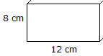 | Problem 2
Wednesday | Simplify:  2.53 x 0.7 | Given angle 6 is 65, identify all missing angles  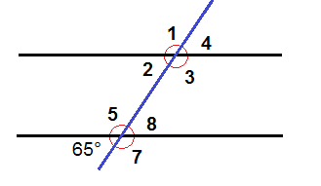 | Problem 1
Thursday | According to the histogram, how many students scored an 80 or higher?  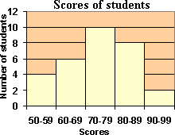 | Write an expression for the following situation and solve.  In the first quarter of a football game, Cam gained 15 yards, lost 2 yards, gained 6 yards, gained 2 yards, and then lost 4 yards. | Problem 1
Friday | Place the following numbers in ascending order and then grid in the greatest value.  $$\frac{18}{5}, 3\frac{2}{3}, 3.65$$ | Solve the equation for x.  2x + 5 = 11 | Problem 1

