 | Problem 1 | Problem 2 | Gridded Response
Monday | Round the following to the nearest tenth:  - 58.629 =  - 3.25 =  - 8.3498 = | Convert the following to improper fractions:  - 3$\frac{5}{12}$ =  - 5$\frac{2}{5}$ =  - 2$\frac{3}{15}$ = | Problem 2C  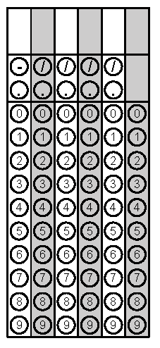
Tuesday | Find the area and perimeter for the figure below.  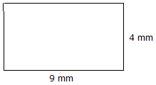 | Mr. Garcia’s class earned a pizza party for selling the most fundraising in the school. His class has 30 students. If pizzas have 8 slices each and each student will eat 2 pieces of pizza, how many pizzas should he order? | Problem 2
Wednesday | Solve the equation for y  3(y – 2) =12 | Katie’s cell phone bill is automatically deducting $49 from her bank account every month. As an integer, how much will the deductions total for the year? | Problem 2
Thursday | Jake wants to buy a pair of pants that cost $35.95, a package of 6 pairs of socks for $12.99, a shirt for $45.95, and a tie for $19.99. If he has $150, how much change will he get from the cashier? | Covert the repeating decimals to fractions  0.21  0.21 | Problem 1
Friday | If two angles of a triangle measure 45 and 63, what is the measure of the missing angle? | Find the measure of angle 5  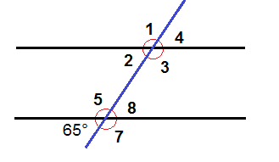 | Problem 1

