 | Problem 1 | Problem 2 | Gridded Response
Monday | Identify the following numbers as rational (terminating or repeating decimals) or irrational (decimals do not end)  - 6.325 _________  - 7/2 _________  - $\sqrt{245}$ _________  4.) $π$ _________ | Kiana needs 76 paper plates for a birthday party. She already has 35 blue plates and 10 red plates. How many more plates should Kiana buy? | Problem 2  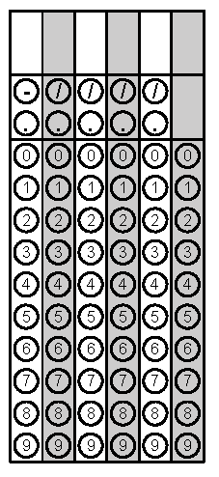
Tuesday | Solve the equation for x  3(x – 2) = 3x -6 | Find the unknown side on the right triangle (use Pythagorean Theorem)  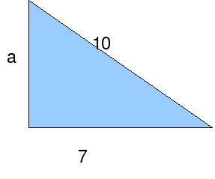 | Problem 2
Wednesday | 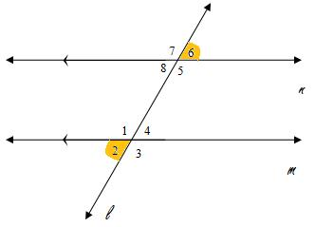  Identify the angle relationship | 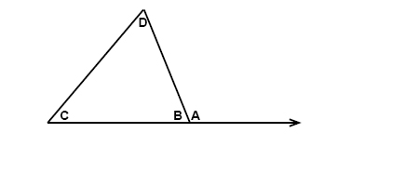  If angle C is 45 and angle D is 72, what is the measure of angle A? | Problem 2
Thursday | Order the numbers from least to greatest  1.2 x 10⁵, 1.2 x 10⁶, 3.4 x 10⁵ | Simplify  $$\sqrt{3+61}$$ | Problem 2
Friday | Are the following images similar?  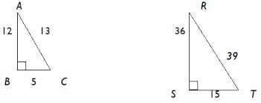 | Evaluate the expression when x = 2 and y = 6  3x + y² - 37 | Problem 2

