 | Problem 1 | Problem 2 | Gridded Response
Monday | The sum of a number and 57 is 43. What is the number? (Hint: use a variable to represent the number) | Nyasia always takes the same route when she walks her dog. First, she walks 7 blocks to the park. Then she walks 9 blocks to the elementary school. Finally, she walks12 blocks to get back home. Nyasia walks her dog 2 times each day. How many blocks does Nyasia's dog walk each day? | Problem 2  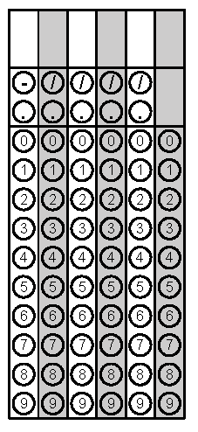
Tuesday | Identify the following as Rational(can be written as a fraction) or Irrational (does not end)  1.) 2.469 ___________  2.) $\frac{54}{9}$ ___________  3.) $\sqrt{34}$ ___________  4.) $0.2\overline{5}$ ___________  5.) -34 ___________ | Convert the repeating decimal to a fraction  $0.2\overline{5}$ | Problem 2
Wednesday | Convert from standard to scientific notation  0.0000008709 | Solve the equation for x  3(2x +2) = 4x | Problem 2
Thursday | Simplify. Answer in Scientific Notation  $$\frac{2.4 x {10}^{5}}{8 x {10}^{3}}$$ | Identify the missing angle  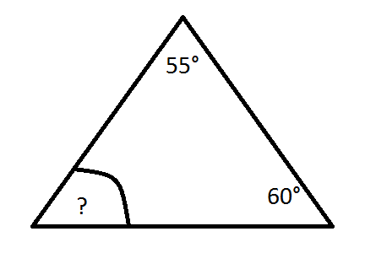 | Problem 2
Friday | Solve the equation for x  12x + 3 = 4 + 12x | Solve for x  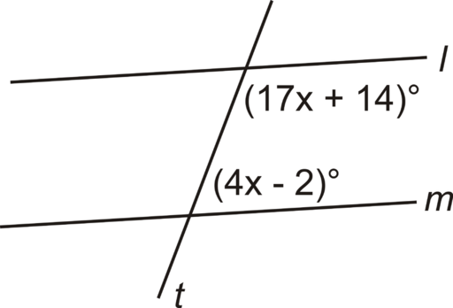 | Problem 2

