 | Problem 1 | Problem 2 | Gridded Response
Monday | Simplify:  4.3 x 10³ + 3 x 10² | Kiana needs 76 paper plates for a birthday party. She already has 35 blue plates and 10 red plates. How many more plates should Kiana buy? | Problem 2  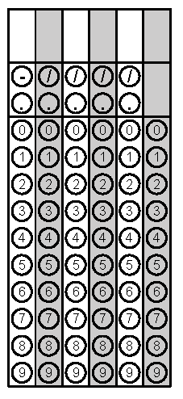
Tuesday | Solve the equation for x  3(x – 2) = 3x -6 | Find the unknown side on the right triangle  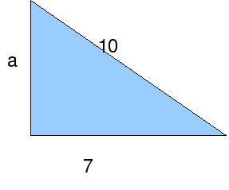 | Problem 2
Wednesday | 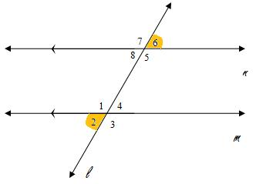  Identify the angle relationship | Solve for x  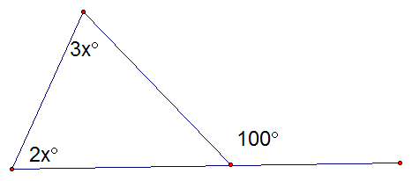 | Problem 2
Thursday | Order the numbers from least to greatest (Hint: Look at exponents first)  1.2 x 10⁵, 1.2 x 10⁶, 3.4 x 10⁵ | Simplify  $$\sqrt{3+61}$$ | Problem 2
Friday | Are the following images similar?  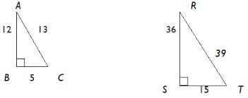 | Simplify. Bubble the exponent in the box (Power to a Power – Multiply exponents)  (y²)⁵ | Problem 2

