 | Problem 1 | Problem 2 | Gridded Response
Monday | Combine like terms  3y + 34 – 2 + 7y – 2y + x – 2x | A cone has a height of 5in and a radius of 3in. What is the volume? | Problem 2  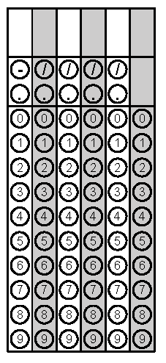
Tuesday | Find the value of x  3x + 2 = 11 | You are trying to find the missing side of a right triangle. The hypotenuse is 12 and one of the legs is 4. | Problem 1
Wednesday | Identify the following numbers as rational or irrational  - 6.325 _________  - 7/2 _________  - $\sqrt{245}$ _________  - $π$ _________ | Simplify the expression. Bubble in the exponent (Multiply Powers - Add exponents)  (3²)(3⁴)(3¹⁰) | Problem 2
Thursday | Find the area of the figure below.  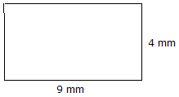 | Find the measure of angle 5  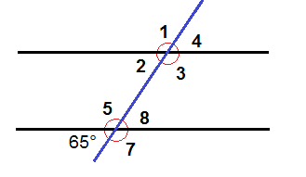 | Problem 2
Friday | Simplify  3.6 x 10² - 4.9 x 10⁵ | The angles of Triangle ABC are:  A = 2x B = x + 3 and C = x  Solve for x. | Problem 2

