 | Problem 1 | Problem 2 | Gridded Response
Monday | Simplify:  3³ + 5 + 4² | Christina's father gave her $136. Christina bought 6 books, each of which cost $6. How much money does Christina have left? | Problem 2  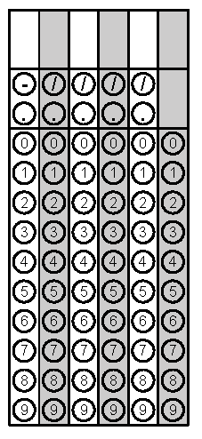
Tuesday | Solve the equation for x  3(x + 2) = 3x + 6 | 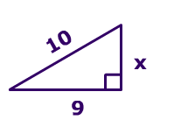  Find the missing side length of the Right Triangle | Problem 2
Wednesday | 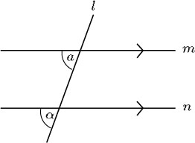  Identify the angle relationship. Are congruent or supplementary? | A plumber charges $50 for a service call plus $25 per hour. If the total cost was $125, how many hours was he at your house? | Problem 2
Thursday | Identify the two PERFECT SQUARES that $\sqrt{212}$ falls between | 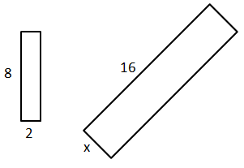  The figures below are similar. Find the missing side length | Problem 2
Friday | Simplify by combining like terms  15x + 2x + 9y² – 13 + 2 | Solve the equations for x.  $$\frac{x}{10 }+2=8$$ | Problem 2

