 | Problem 1 | Problem 2 | Gridded Response
Monday  (No Calculator) | (3,5) (4,2) (3,2) (7,6)  Domain:_________________  Range:__________________  Function / Not a Function | Convert the fraction into a decimal  $$\frac{29}{100}$$ | Problem 2  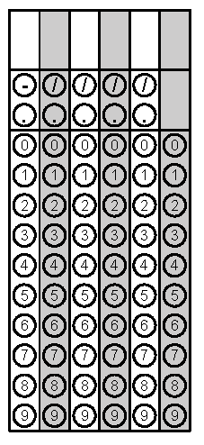
Tuesday | Graph the points (3,4) (-2,1)  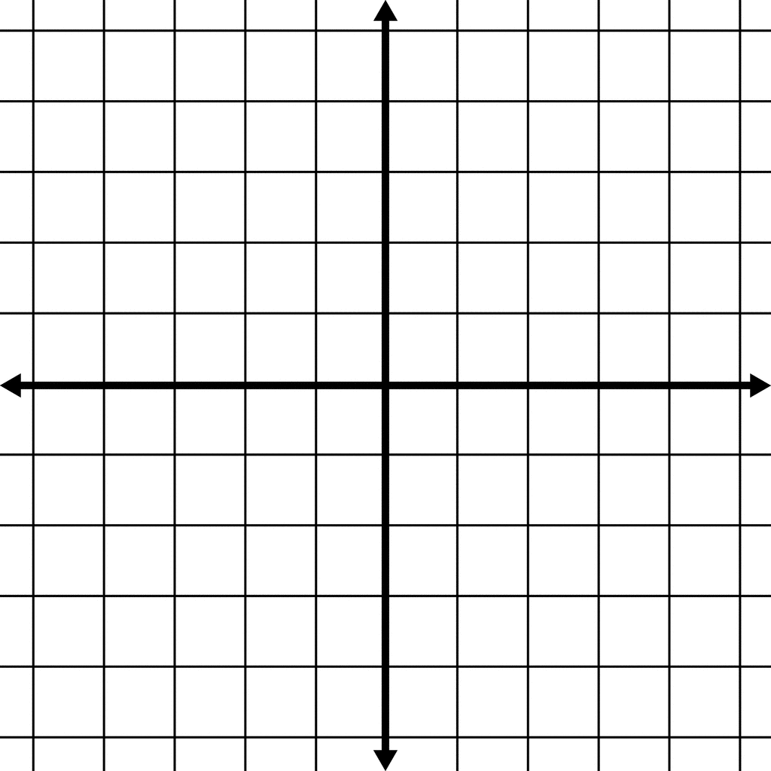  M = | Solve the equation for x  4x – 2x + 5 = 15 | Problem 2
Wednesday | Circle all categories that apply to the real number  -6/3  Irrational, Rational, Integer, Whole, Natural | Find the side length of the right triangle.  A= 5, B = ? C = 10 | Problem 2
Thursday | Simplify  $$\frac{3x^{4}\left(x^{3}\right)}{x^{5}}$$ | Find the Rate of Change (Slope) from the table  X Y  3 9  2 12  0 18 | Problem 2
Friday | Identify the type of slope as positive, negative, zero, undefined  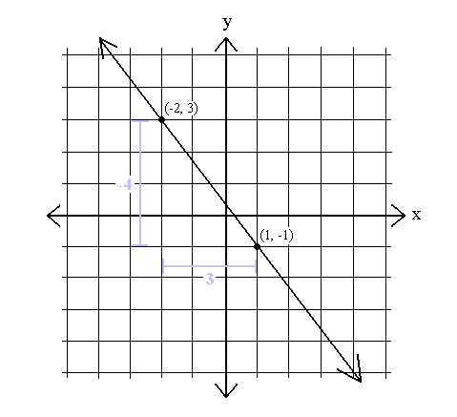 | 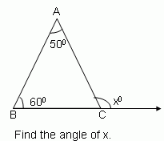 | Problem 2

