 | Problem 1 | Problem 2 | Gridded Response
Monday  (No Calculator) | About 602,000,000 tons of corn are harvested each year. What is 602,000,000 in scientific notation? | Which integer is - $\sqrt{27}$ closest to? | Problem 2  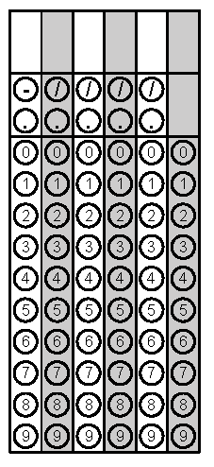
Tuesday | Write an equation of the line with a y-intercept of 7 and a slope of – 2  (Hint: y = mx + b) | Solve the equation for x  2(3x -5) = 5x + 4 | Problem 2
Wednesday | (-2,6) (8,2) (7,4) (9,6)  Input:_________________  Output:__________________  Function / Not a Function | Find the volume of the figure below  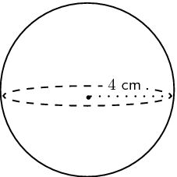 | Problem 2
Thursday | Order the numbers in scientific notation for greatest to least  2.1 x 10⁴, 2.1 x 10⁸,  1.7 x 10⁶, 8 x 10⁴ | Simplify  3(5 + 4) - 2² | Problem 2
Friday | y = 2x y = ½ x y = 5x  Which equation has the  Steepest slope? _________  The Flattest? ___________ | The weekly salaries of six employees at McDonalds are  $140, $220, $90, $180, $140, $200.  Find the median value | Problem 2

