 | Problem 1 | Problem 2 | Gridded Response
Monday | Amy is making cookies for teacher appreciation day. She makes 7 dozen cookies. If she has 8 teachers and wants to give all the same amount of cookies. How many cookies will she have left over? | To fill the swimming pool, it costs $1 per cubic foot. What is the total price you would have to pay to fill the pool below?  8 ft  12 ft  4 ft | Problem 2  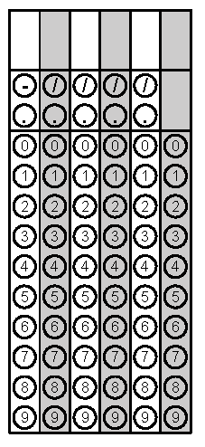
Tuesday | What is $2^{3}×3^{2}×5$ ? | Northwest Middle School observes 1,805 car drop off or pick up students daily. How many cars drop off or pick up for the month of September (30 days). | Problem 2
Wednesday | Evaluate using order of operations.  $$4\left\{\left(2×3\right)\right\}+3$$ | Compare using <, >, or =.  $8^{3}$ and ${\left(4×6\right)}^{2}$ | Problem 1
Thursday | Write 6x6x6x6x6x6x6x6 in exponential form, bubble in the exponent | Brenda’s room is 12 feet wide by 6 feet long. Her brother’s room is half as wide but twice as long. Whose room is bigger? | Problem 1
Friday | Sammie had $20.25 but then she dropped her zippered pouch and lost 4 quarters, 13 dimes, eight nickels, and nineteen pennies. How much money does she have left? | Write using exponential notation.  $$8^{2}×8^{4}=$$  ${ \left(2^{3}\right)}^{4}=$  $\frac{3^{8}}{3^{2}}=$ | Problem 1

