 | Problem 1 | Problem 2 | Gridded Response
Monday | What is the greatest common factor (GCF) of 16 and 21? | Find the perimeter of the shape below.  2 cm  2 cm  5 cm  2 cm | Problem 1  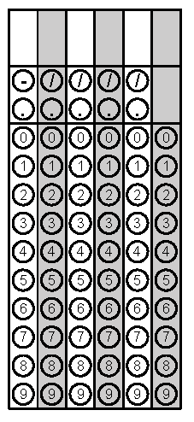
Tuesday | Hot dogs are sold in packs of 8 and buns are sold in packs of 6. If you want exactly one hot dog for each bun, what is the least number of packs of each would you need to buy? | Find the missing value in this function table.  x y  1 5  7 9  10 ?  13 17 | Problem 2
Wednesday | Which is greater: the product of $5$ and $\frac{4}{5}$ or the quotient of $5$ and $\frac{4}{5}$? | Evaluate:  $$2^{3}+{\left(7-3×2\right)}^{3}$$ | Problem 2
Thursday | Evaluate:  1,452 ÷ 12 | In a race, the following finish times were recorded. Who was the fastest?  Sprinter Time (sec)  Joe 8.145  Aaniah 8.015  Carlos 8.21  Payton 8.253  Edward 8.028 | Problem 1
Friday | Haley treats her friends to a movie and snacks. How much will she spend 3 movie tickets, one popcorns, and 3 drinks?  Ticket $6.25  Popcorn $6.50  Candy $3.75  Nachos $4.80  Drink $3.65 | $$2\frac{1}{5}-1\frac{2}{3}$$ | Problem 1

