 | Problem 1 | Problem 2 | Gridded Response
Monday | Which figure has the largest volume?  Figure L W H  Pink 4 cm 7 cm 2 cm  Blue 5 cm 8 cm 1 cm  Green 8 cm 2 cm 3 cm | Jaronte’s grandmother walked 1.2 miles twice a day for one week. What is the total number of miles she walked in one week? | Problem 2  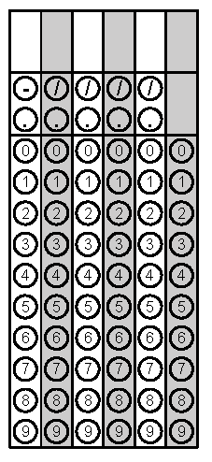
Tuesday | Abe has 8 quarters, 3 dimes, and 10 nickels. How much money does he have? | How many erasers can he buy if he also needs to purchase 3 pencils?  Item Price  Pencil $0.85  Pen $1.30 | Problem 1
Wednesday | What is the expanded form of $2^{4}$ ? | Find the volume.  15 ft  3 ft  3 ft  5 ft  8  ft | Problem 2
Thursday | Eli’s chocolate chip cookie recipe calls for $1\frac{3}{4}$ cups of sugar. If he needs to make eight batches, how much sugar will he need? | Which terms are Like Terms?$4x, -4y, -x, 4x^{2}$ | Problem 1
Friday | Find the quotient of 21.35 and 3.5. | Your favorite clothing store is having a 25% off sale. How much will you spend on two $12 shirts and a pair of $26 jeans? | Problem 2

