 | Problem 1 | Problem 2 | Gridded Response
Monday | A hot dog cart sold $937.50 worth of hot dogs during the street fair. If hot dogs cost $2.50 each, how many were sold? | $$\frac{6}{3}- \frac{5}{12}$$ | Problem 1  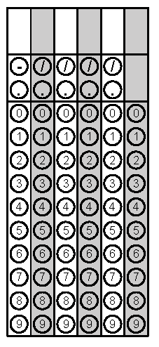
Tuesday | Solve: $x-2>5$ | Evaluate using order of operations.  $$4\left(13+8\right)-8^{2}÷(2∙4)$$ | Problem 2
Wednesday | Evaluate.  $${\left(\frac{3}{5}\right)}^{3}$$ | Nick built this prism using cubes. What is its volume?  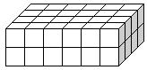 | Problem 1
Thursday | Jim will go fishing 24 times this month. If a monthly pass is $20 and a daily pass is $3, how much money will he save this month if he buys the monthly pass? | A dozen eggs cost $1.32. How much does one egg cost? | Problem 1
Friday | What is the Least Common Multiple (LCM) of 6 and 4? | Antonio earns $6.50 each week in allowance and earns some extra money by taking care of his neighbor’s dog while they are on vacation. If the neighbors pay $5.50 each day for pet sitting, how much will he earn this week for five days of pet sitting plus his allowance? | Problem 2

