 | Problem 1 | Problem 2 | Gridded Response
Monday | During gym class, students measured their long jumps. Who can jump the farthest?  Student Distance (m)  Annie 12.45  Billy 12.4  Carter 12.451  DeShaun 12.04  Erik 12.401 | Simplify:  $12-(\frac{9}{3}+2)$ | Problem 2  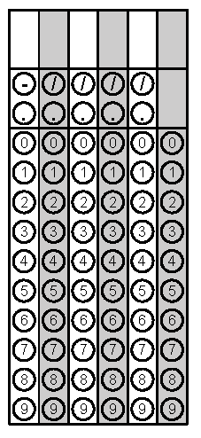
Tuesday | Sally has 9 quarters, 27 dimes, and 5 nickels. How much money does she have? | Maggie and her mom buy 9 yards of ribbon to make bows for her party. Each bow requires $\frac{2}{3}$ yard of ribbon. How many bows can they make? | Problem 1
Wednesday | There are 30 students in a class. 10 are boys. Write a ratio comparing boys to total students. | 30.41 x 3.2 | Problem 2
Thursday | During gym class, students measured their long jumps. Who can jump the farthest?  Student Distance (m)  Nathan 14.01  Jason 14.13  Jane 14.105  Tony 14.125  Quinton 14.118 | Mrs. Splain’s class made a line plot to show the number of states each student has visited. How many students have visited less than 3 states?  X  X X X X  X X X X X  X X X X X  1 2 3 4 5  States Visited | Problem 2
Friday | Write the following phrase algebraically.  “Five times the sum of a number and 3”  * Let ____ = a number | Susanna went to the mall to spend her birthday money of $75. She bought a pair of jeans for $24.99, two shirts for $15.50 each, and a jacket for $18.30. After her mom treated her to lunch, she decided to return the jacket. How much money does Susanna have now? | Problem 2

