 | Problem 1 | Problem 2 | Gridded Response
Monday | Write in exponential form.  (3)(3)(3)(3)(x)(x)(y)(y)(y) | Two more than 3 times a number is 26. What is the number? | Problem 2  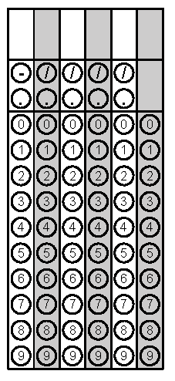
Tuesday | Solve for S | Solve the equation for x  4x – 5x +7 = 18 | Problem 2
Wednesday | Convert from scientific notation to standard form  -4.203 x 10⁶ | 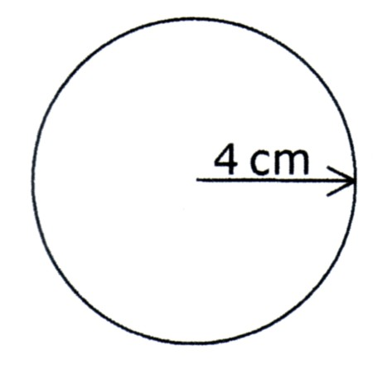  Find the area of figure below | Problem 2
Thursday | Simplify  $$\frac{(x^{5})(x^{4})}{x^{2}}$$ | What is the measure of the unknown angle?  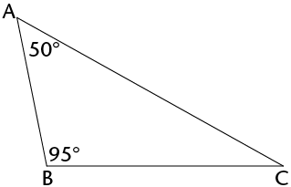 | Problem 2
Friday | Solve for the unknown side  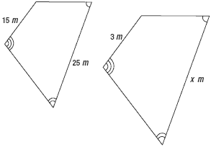 | Estimate the Square Root to the nearest tenth  $$\sqrt{176}$$ | Problem 2

