 | Problem 1 | Problem 2 | Gridded Response
Monday | Complete the following problem with integers.  72 x (-2) | Anthony is a great babysitter. He makes $9 an hour. Mary is an even better babysitter. She makes $12 an hour. Mary works 6 hours each week. How many hours does Anthony need to work in order to earn as much money as Mary earns in a week? | Problem 2  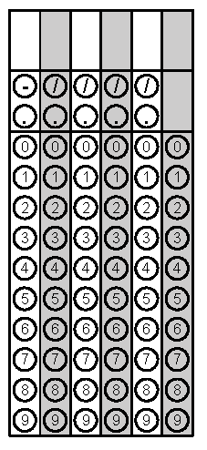
Tuesday | Change to scientific notation: 0.003109 | Which integer $\sqrt{145}$ is closest to? (Hint: Find the perfect squares in falls between) | Problem 2
Wednesday | Plot the following numbers on a number line  -3.5, $\sqrt{9}$, 0.45, -2 | Simplify  (5x² y)⁰ | Problem 2
Thursday | Simplify the expression  $\frac{8x^{9}}{2x^{3}}$ | Solve the equation for x  4x + 2 = 22 | Problem 2
Friday | Combine like terms  5x + x² + 2x + 5 – 4 – x² | The area of the surface of the Atlantic Ocean is approximately 32,000,000 square miles. How is this area written in scientific notation?  (bubble the exponent) | Problem 2

