 | Problem 1 | Problem 2 | Gridded Response
Monday  (No Calculator) | List the first 10 perfect squares | Convert the fraction into a decimal  $$\frac{24}{99}$$ | Problem 2  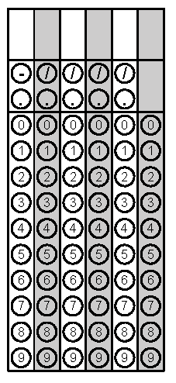
Tuesday | Graph y = 2x + 1  m= b=  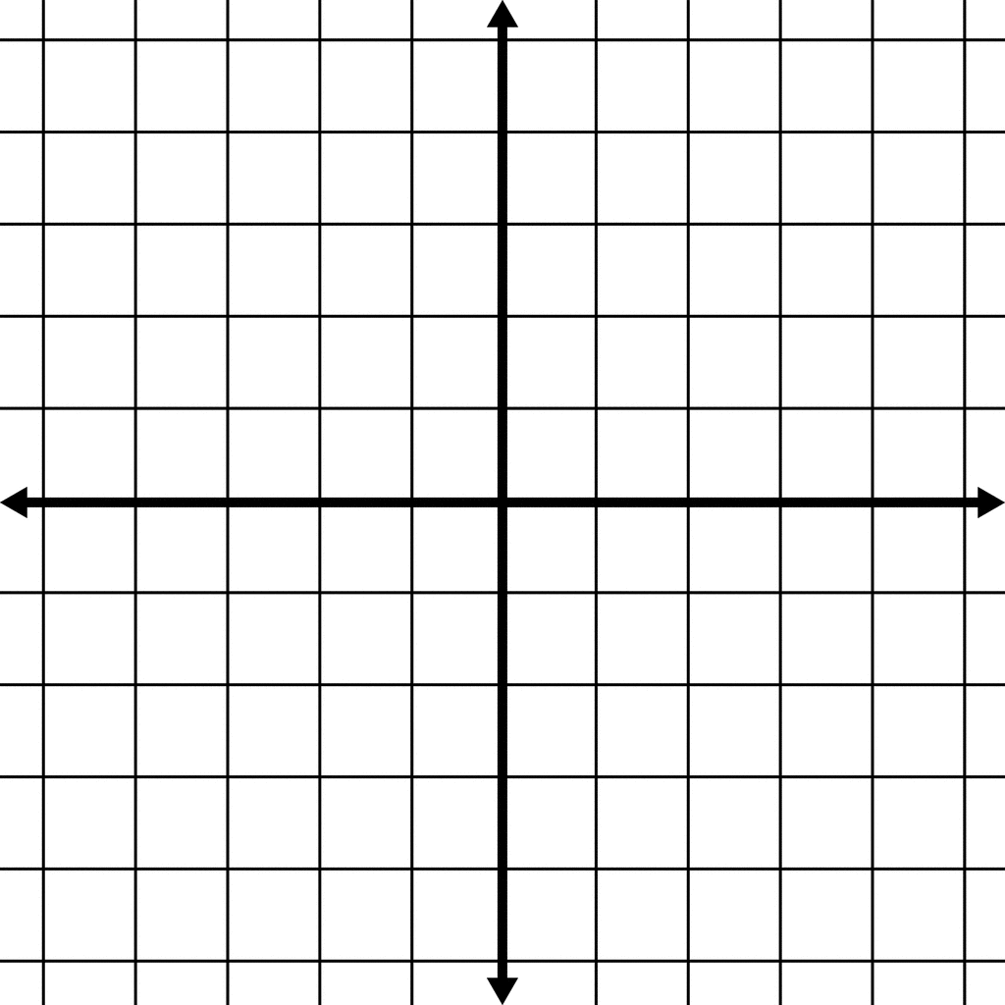 | Solve the equation for x  16 = -2 + 3x | Problem 2
Wednesday | Identify the follow as:  Irrational, Rational, Integer, Whole, Natural  - 34.52 ___________  - – 25 ___________  - 6/3 ___________  - $\sqrt{35}$ | 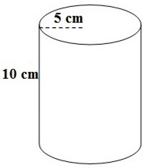  Find the volume of the figure below | Problem 2
Thursday | Write the equation from the graph  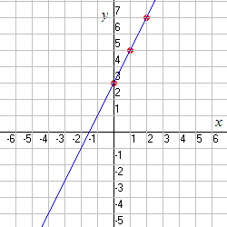  m = b =  Equation: | Convert the number into scientific notation. Bubble in the exponent  0.00000342 | Problem 2
Friday | Identify the type of correlation  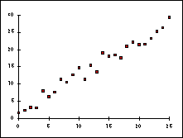 | Write an equation using the table  X Y  2 4  0 8  -2 12  m =  b =  Equation: | Problem 2

