 | Problem 1 | Problem 2 | Gridded Response
Monday  (No Calculator) | Order the numbers in ascending order (least to greatest)  -2 , - ½ , ¾ , ½ , 1 | Simplify (bubble in the exponent)  (x³) (x²) | Problem 2  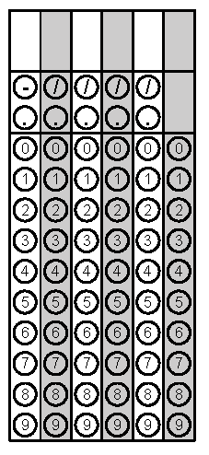
Tuesday | Graph y = - x + 4  m= b=  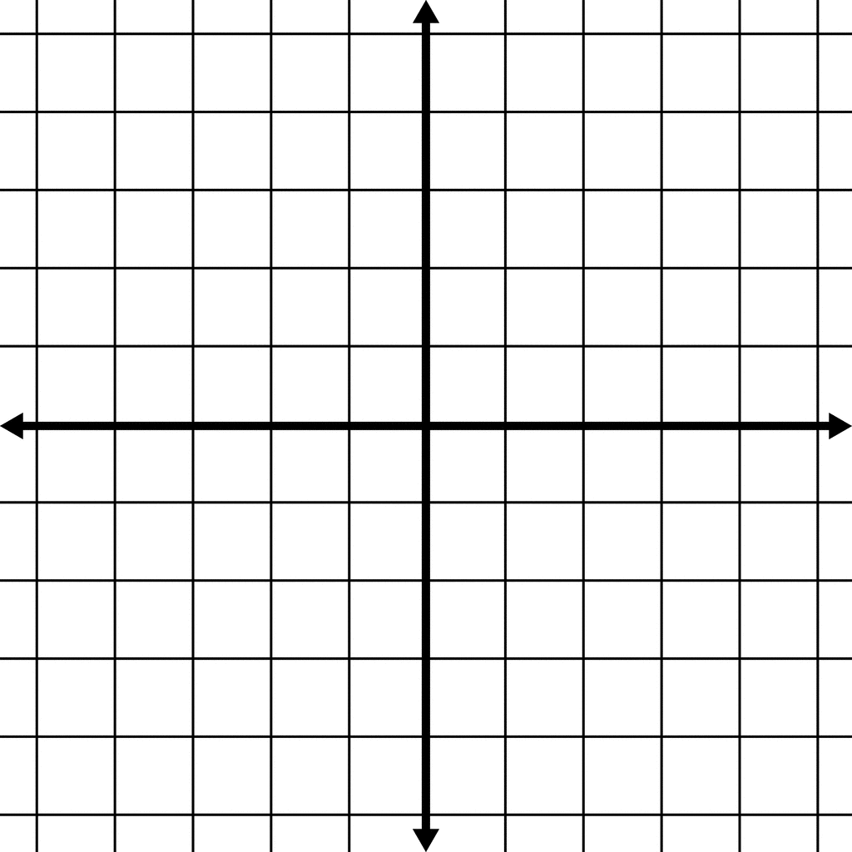 | Solve 3x + 2 – y + x  when x = 4 and y = 5 | Problem 2
Wednesday | Identify the measure of angle 1 when angle 2 is x + 45  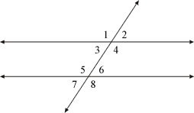 | Find the volume of the figure below  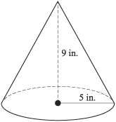 | Problem 2
Thursday | 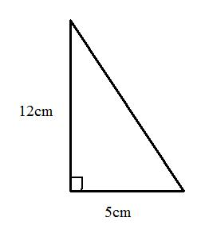  Find the missing side length of the right triangle | What is John’s average in math if he scored the following on his test  87, 93, 54, 80, 75 | Problem 2
Friday | Identify the type of correlation  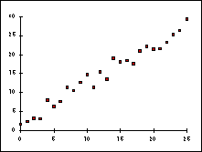 | Write an equation using the table  X Y  2 4  0 8  -2 12  m =  b =  Equation: | Problem 2

