 | Problem 1 | Problem 2 | Gridded Response
Monday  (No Calc.) | Which is equivalent to 5 ⁻ ²  A. -25  B. – 10  C. $\frac{1}{25}$  D. $\frac{1}{10}$ | Jill called to schedule a plumber. She was charged an initial fee of $50 plus $80 for every hour the plumber was at her house.  Write an equation to represent the total cost. (Hint. y = mx + b) | Problem 2  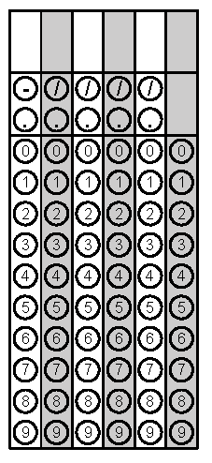
Tuesday | 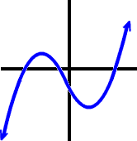  Function or not a function? Why? | Convert the repeating decimal to a fraction  $0.6\overline{2}$ | Problem 2
Wednesday | Answer in Scientific Notation  (3.4 x 10⁴ ) + (5.8 x 10⁶ ) | Solve the equation for b when x = 2, y = 12, and m = 3  y = mx + b | Problem 2
Thursday | Complete the Function Table  x 2x + 3 Y  -1  0  1  2 | Identify the missing angle  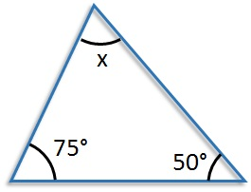 | Problem 2
Friday | Draw the line of best fit and identify the type of correlation  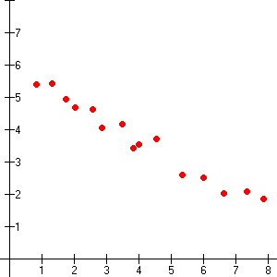  Correlation_____________ | What is the value of  $$\sqrt{\frac{4}{25}}$$ | Problem 2

