 | Problem 1 | Problem 2 | Gridded Response
Monday  (No Calculator) | Circle the equation that is NON-LINEAR  Y = 3x + 2  Y= ¼ x – 7  Y = 2x²  Y = 12 | Estimate $\sqrt{38}$ to the nearest tenth | Problem 2  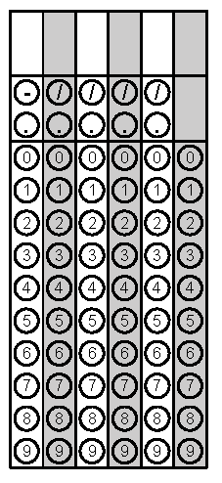
Tuesday | Graph y = x  m= b=  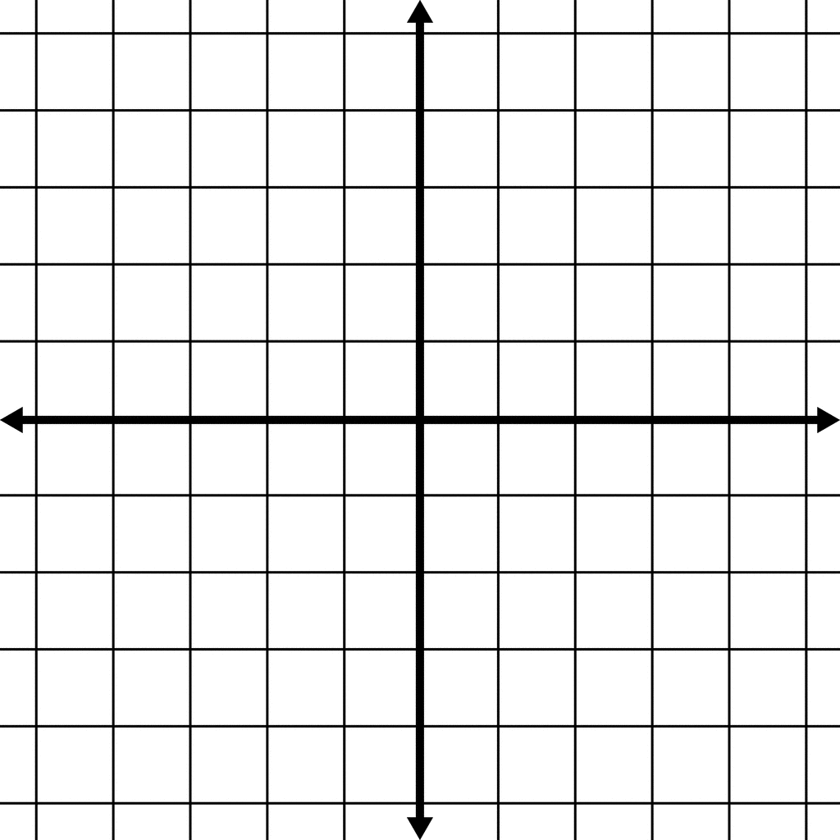 | Convert to scientific notation. Bubble in the exponent  45,000,000,000,000 | Problem 2
Wednesday | A rental car company charges a flat rate of $50 plus $2 every hour. Write an equation to represent the total cost of renting a car. | Find the volume of the figure below  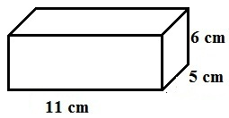 | Problem 2
Thursday | Complete the Function Table  x x² -1 Y  -1  0  1  2 | Solve the equation for x  $\frac{x}{2}$ – 5 = 12 | Problem 2
Friday | Write an equation with the same y-intercept whose slope is steeper than  y = 2x + 3 | The weekly salaries of six employees at McDonalds are  $140, $220, $90, $180, $140, $200.  Find the mean. | Problem 2

